# Diabetes Classification Results using RandomForest

## Classification Report:

precision recall f1-score support  
  
 0 0.80 0.76 0.78 146  
 1 0.78 0.82 0.80 154  
  
 accuracy 0.79 300  
 macro avg 0.79 0.79 0.79 300  
weighted avg 0.79 0.79 0.79 300

## ROC AUC Score:

ROC AUC Score (RandomForest): 0.8785803237858033

## ROC Curve:

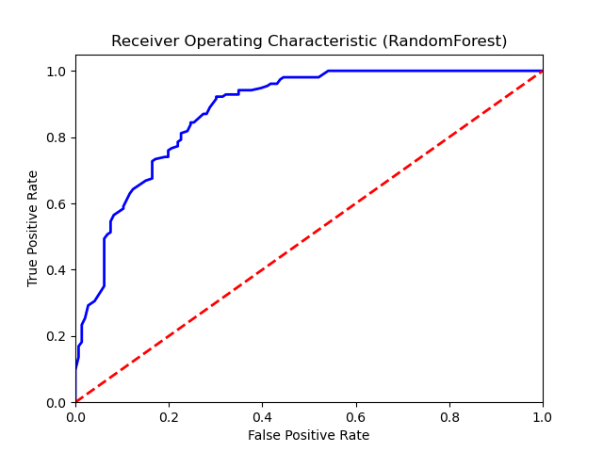

## Confusion Matrix:

True Negatives: 111

False Positives: 35

False Negatives: 28

True Positives: 126

## Confusion Matrix Plot:

